**Part One**

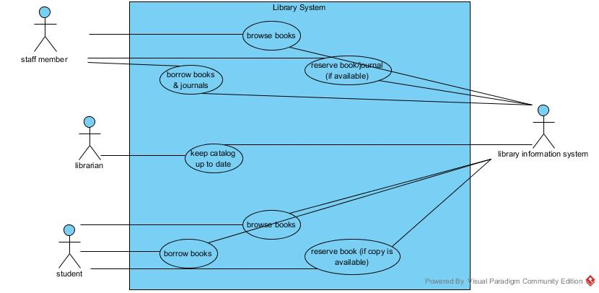

**Part Two**

Use-case: Staff terminal user

1. Description: staff member can browse, reserve and check out books & journals through the library system terminal.
2. Actors: staff member
3. Triggers: customer uses a library terminal to access the library system
4. Preconditions: library system is active
5. Scenario: A staff member approaches a library system terminal. The staff member browses through the collection of books & journals, decides which ones to choose, and provides user data. Books and journals are available for pickup at that time.
6. Exceptions:
   1. book/journal is currently checked out
   2. library doesn’t carry the chosen book/journal
7. Post-condition: Books and journals are available for pickup
8. Alternative flow: A staff member approaches a library system terminal. The staff member browses the collection of books & journals, reserves the item(s), and provides user data for verification. Reservation information is available to the staff member.

Use-case: Student terminal user

1. Description: student member can browse, reserve and check out books through the library system terminal.
2. Actors: student member
3. Triggers: customer uses a library terminal to access the library system
4. Preconditions: library system is active
5. Scenario: A student member approaches a library system terminal. The student member browses through the collection of books, decides which ones to choose, and provides user data. Books are available for pickup at that time.
6. Exceptions:
   1. book is currently checked out
   2. library doesn’t carry the chosen book
7. Post-condition: Books are available for pickup
8. Alternative flow: A student member approaches a library system terminal. The student member browses the collection of books, reserves the item(s), and provides user data for verification. Reservation information is available to the staff member.

Use-case: Librarian user

1. Description: librarians use the library system to keep the catalog up to date
2. Actors: librarian
3. Triggers: librarian uses library system terminal
4. Preconditions: library system is active
5. Scenario: Librarian approaches a library system terminal. Librarian adds books/journals to catalog.
6. Exceptions: none
7. Post-condition: catalog is updated
8. Alternative flow: Librarian approaches a library system terminal. Librarian removes books/journals to catalog.

Use-case: Library information system

1. Description: the library information system, used by the library system, contains a database of all books and journals and users.
2. Actors: library information system (secondary actor )
3. Triggers: librarian, staff member or student member use the library system.
4. Preconditions:
   1. library system is active
5. Scenario: Librarian, student member, staff member access the library system terminal. Library information system is accessed by the library system. Librarian alters the library system by altering the catalog
6. Exceptions: none
7. Post-condition: catalog is updated
8. Alternative flow Librarian, student member, staff member access the library system terminal. Library information system is accessed by the library system. Librarian does not alter the catalog.

**Part Three**

1. As a student member I want to access the library system so I can browse, reserve and borrow books.
2. As a staff member I want to access the library system so I can browse, reserve and borrow books & journals.
3. As a librarian I want to access the library system so I can keep the catalog up to date.
4. As a library information system, I want to be accessed by the library system, to allow student members, staff members to browse, reserve and check out items & allow librarians to keep everything updated.